PROJECT DOCUMENTATION

Fit Flex: Your Personal Fitness Companion



Project Title: FitFlex_Your Personal Compansion

Team ID : NM2025TMID36533

Team Leader:

* Harine.M. A- [24csharine030@gmail.com](mailto:24csharine030@gmail.com)

Team member :

* Haripriya .B- [24csharipriya031@gmail.com](mailto:24csharipriya031@gmail.com)
* Hemavarshini . V- [24cshemavarshini032@gmail.com](mailto:24cshemavarshini032@gmail.com)
* Hemavarshini . M- [24cshemavarshini033@gmail.com](mailto:24cshemavarshini033@gmail.com)

Purpose / Overview:

* FitFlex is designed to act as a personal health and fitness assistant for users who want to stay consistent with their fitness journey. The application helps users track workouts, monitor diet and water intake, set daily goals, and analyze their progress visually.
* Its main purpose is to motivate users to maintain a healthy lifestyle by providing reminders, insights, and progress reports in one centralized platform. FitFlex is ideal for fitness beginners as well as experienced users who want an easy, digital way to manage their health routines.
* Its primary purpose is to help users stay consistent with their health goals by tracking workouts, diet, water intake, and overall progress.
* It provides motivation, reminders, and analytics to encourage users to build and maintain a healthy lifestyle.

Introduction / Abstract

In today’s fast-paced world, maintaining a healthy lifestyle has become a challenge for many individuals. Busy schedules, lack of motivation, and limited access to professional trainers often lead to inconsistent fitness routines. FitFlex – Your Personal Fitness Companion was developed to address these challenges by providing a virtual, accessible, and engaging fitness solution.

* FitFlex is a web-based platform that acts as a personal fitness assistant, offering:
* Customized workout recommendations based on user goals, available time, and fitness level.
* Daily tracking features to log exercises, calories burned, and progress.
* Visual dashboards and charts to monitor weekly and monthly performance.
* Motivational reminders to encourage consistency and build healthy habits.
* The application is designed with a user-friendly interface, making it easy for people of all age groups to adopt. The project leverages modern web technologies (React.js, Node.js, MongoDB) to ensure smooth performance, responsive design, and secure data management.
* The primary objective of this project is to promote health and well-being by making fitness accessible, flexible, and personalized. By integrating technology with health, FitFlex empowers users to stay active, track their journey, and achieve their fitness goals without the need for an expensive personal trainer or gym subscription.

Objectives

* The main objectives of FitFlex – Your Personal Fitness Companion are:
* Provide Personalized Fitness Plans – Suggest workouts based on user goals like weight loss, strength, or flexibility.
* Track Daily Activities – Record exercises, calories burned, and progress to encourage consistency.
* Motivate Users – Send reminders and display motivational messages to build healthy habits.
* Ensure Accessibility – Design a simple, mobile-friendly platform that works for all users.
* Offer Flexibility – Allow users to work out anytime, anywhere, at their own pace.

Scope of the Project

The scope of FitFlex – Your Personal Fitness Companion covers the complete fitness journey of a user — from goal setting to progress tracking.

Key Points in Scope:

* User Profile Management – Create, edit, and manage personal fitness profiles.
* Personalized Workout Recommendations – Generate exercise plans based on user goals (weight loss, muscle gain, flexibility).
* Daily Tracking – Record completed workouts, calories burned, and workout duration.
* Progress Visualization – Display weekly/monthly progress using charts and graphs.
* Motivational Support – Provide daily reminders, tips, and health advice.
* Responsive Web Design – Ensure smooth usage on desktops, tablets, and smartphones.
* Data Security – Keep user information safe with proper authentication and storage.

Modules & Features

FitFlex is designed as a modular system so that each part of the application works independently yet integrates seamlessly.

1. Authentication Module

Features:

* User Registration & Login
* Password Reset
* Secure Authentication (basic encryption or JWT support)

2. User Profile Module

Features:

* Create and manage personal profiles
* Select fitness goals (Weight Loss, Muscle Gain, Flexibility, General Fitness)
* Set workout preferences (Duration, Intensity, Equipment availability)

3.Workout Recommendation Module

Features:

* AI-based or logic-based workout suggestion engine
* Filter workouts based on time availability
* Show exercise instructions (images/video/guides)

4. Tracking & Logging Module

Features:

* Log daily workouts, calories burned, time spent
* Store workout history for future reference
* Track weekly and monthly progress

5. Dashboard & Visualization Module

Features:

* Display progress with charts/graphs
* Show goal completion percentage
* Weekly & monthly summary reports

6. Notifications & Reminders Module

Features:

* Daily motivational messages
* Workout reminders at scheduled times
* Push notifications (future enhancement)

7. Responsive Design & User Interface Module

Features:

* Clean, simple, and mobile-friendly interface
* Fast navigation between sections
* Supports multiple screen sizes

Technology Used

* **Frontend:** HTML, CSS, JavaScript, React.js
* **Styling:** Tailwind CSS
* **Backend:** Node.js, Express.js
* **Database:** MongoDB
* **Charts:** Chart.js / Recharts

Architecture / Workflow

The FitFlex – Your Personal Fitness Companion project follows a three-tier architecture consisting of Frontend (Client), Backend (Server), and Database (Storage).

Workflow Steps:

* User Interaction (Frontend):
* User opens the web application on browser (desktop or mobile).
* Performs actions like login, select fitness goal, or log workout.
* Request Handling (Backend):
* The Node.js + Express server receives the user’s request.
* Validates data, processes workout recommendations, or fetches stored progress.

Database Operations (MongoDB):

* Stores user details, workout history, and progress data.
* Retrieves data when user opens the Dashboard.

Response Back to Frontend:

* Server sends back personalized workout plans or progress statistics.
* Frontend updates the UI (charts, tables, reminders) in real time.

Architecture Diagram (Explained Simply):

* Browser (React App) → API (Node.js/Express) → Database (MongoDB)
* Browser: Displays user interface (login page, workout list, dashboard).
* API: Acts as a bridge between frontend and database.
* Database: Stores user profiles, workout logs, and histor

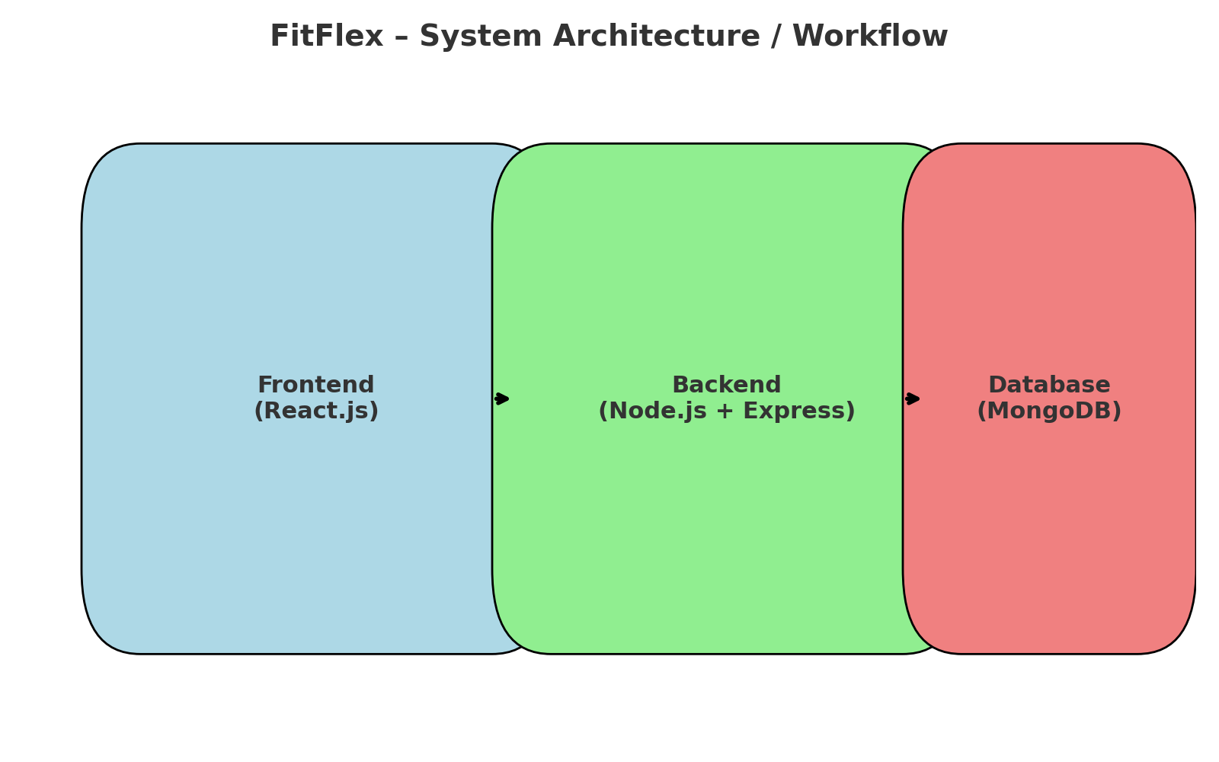

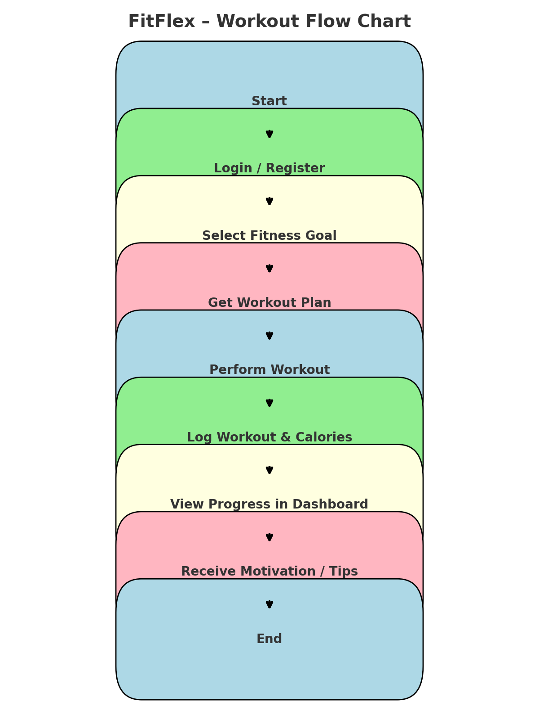

## Advantages

## **24/7 Availability** – Users can access workouts anytime, anywhere.

## **Cost-Effective** – Reduces the need for expensive personal trainers or gym subscriptions.

## **Personalized Guidance** – Suggests workouts based on individual fitness goals.

## **Motivational Support** – Sends reminders and tips to keep users consistent.

## **Progress Tracking** – Allows users to visualize their improvements over time.

## **User-Friendly Interface** – Simple design makes it accessible to all age groups.

* **Flexible & Convenient** – Users can work out at home, office, or outdoors.

## **Future Enhancements**

* **AI-Powered Virtual Coach** – Detect user posture through webcam and provide real-time feedback.
* **Wearable Device Integration** – Sync data with smartwatches and fitness trackers.
* **Voice Assistant Support** – Enable hands-free workout guidance using voice commands.
* **Community & Challenges** – Allow users to connect, share progress, and compete with friends.
* **Offline Mode** – Access workout plans even without internet connection.
* **Diet & Nutrition Plans** – Recommend meals based on user fitness goals

Screenshots:

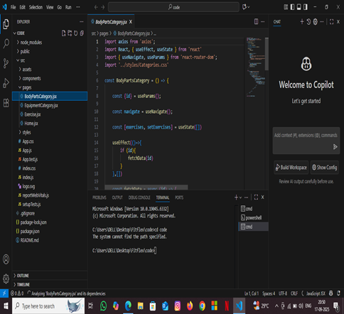

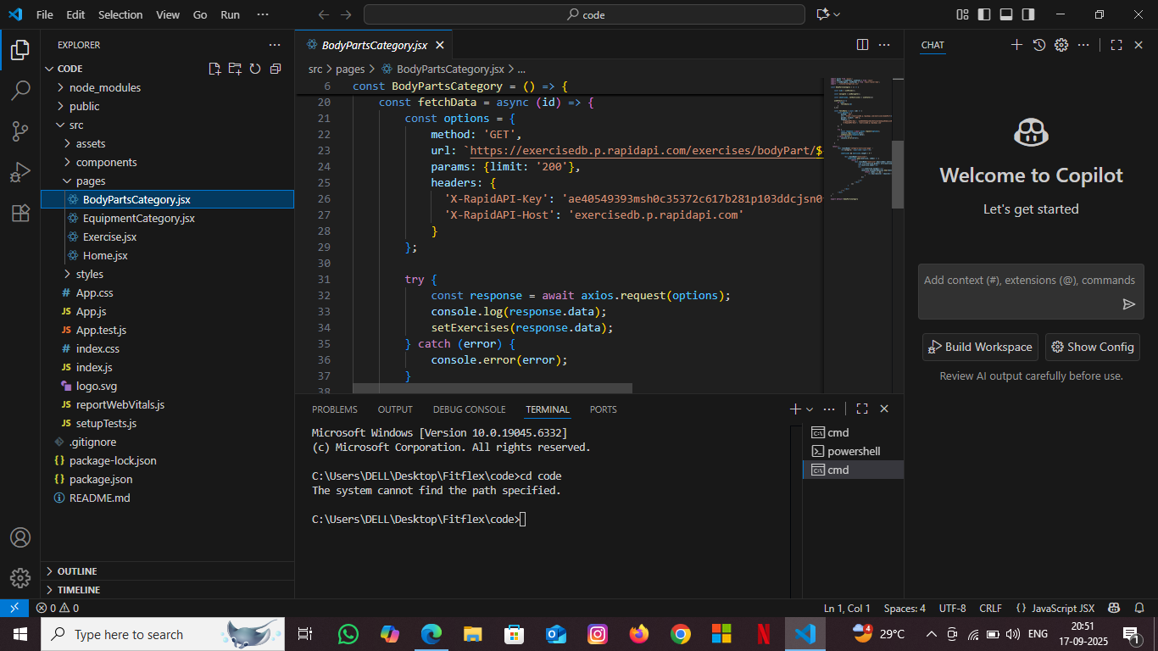

Folder Structure:

fit flex-app/

│

├── src/ → Main source folder

│ ├── App.js → Main application logic (layout + routes)

│ ├── index.js → Entry point of React app (renders <App />)

│ ├── App.css → Styling for your app

│ │

│ ├── components/ → Reusable UI components

│ │ ├── Navbar.jsx → Navigation bar

│ │ ├── Footer.jsx → Footer section

│ │ └── WorkoutCard.jsx → Displays workout information

│ │

│ └── pages/ → Main screens

│ ├── Home.jsx → Landing page

│ ├── Dashboard.jsx → User progress dashboard

│ └── Login.jsx → User login page

│

└── assets/ → Images, icons, static files

Conclusion

Fit Flex – Your Personal Fitness Companion successfully addresses the common challenges faced by individuals trying to maintain a healthy lifestyle. By providing personalized workout recommendations, easy activity tracking, and motivational support, fit Flex makes fitness simple, flexible, and accessible for everyone.

This project demonstrates how technology can encourage users to stay consistent, monitor their progress, and achieve their fitness goals without depending on expensive trainers or gym memberships.

In the future, fit Flex can be expanded with AI coaching, wearable integrations, and social features to make the platform even more engaging and interactive.